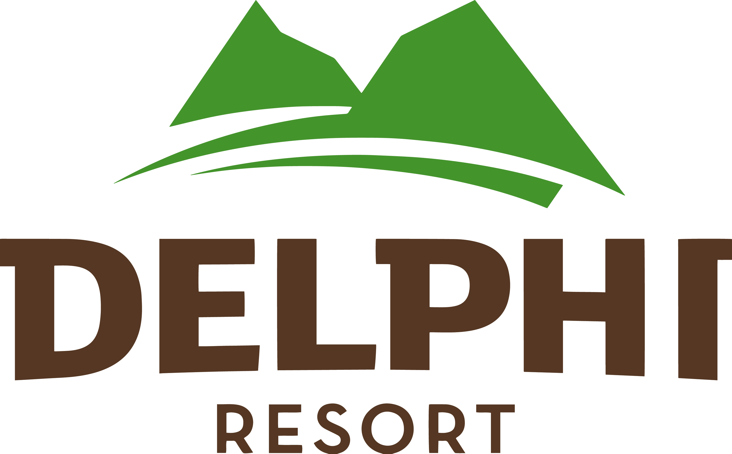
Starters

Guinness Salmon Gravlax
House Pickles & Petite Salad (9, 13, 14)

Goat’s Cheese & Onion Marmalade Pie
Petite Salad (4, 6, 7, 13)

Connemara Smoked Salmon
Pickles, Lemon Aioli, Petite Salad (6, 9, 13, 14)

Ham Hock Terrine
Pear & Gherkin Pickles, Mustard Mayonnaise (6, 13)

Mains

Pan-Seared Fillet of Hake
Smoked Salmon & Pea Risotto (7, 9, 12, 14)

Organic Chicken Supreme
Scallion Mash, Madeira & Wild Mushroom Cream Sauce (7, 12, 14)

8oz Sirloin Steak
Pommes Purée, Wild Mushrooms, Heritage Carrots, Red Wine Jus (7, 12, 14)
(Supplement €5 )

Braised Irish Beef Cheek Bourguignon
Garlic Potatoes, Wild Mushrooms, Roast Jus (7, 12, 14)

Braised Shank of Mayo Lamb
Spinach Purée, Rainbow Carrots, Pommes Purée (7, 12, 14)

Wild Mushroom Tagliatelle
Micro Herbs (4, 6, 7, 12, 14)

Desserts

Apple Tart
Vanilla Ice-Cream (4, 6, 7)

Warm Chocolate Brownie
Vanilla Ice-Cream (2, 4, 6, 7)

Trio of Ice-Cream
White Chocolate Powder (7)

Guinness & Cocoa Nibs Tiramisu
(4, 6, 7)

Delphi Cheeseboard
Selection of Farmhouse Cheeses, Chilli & Apricot Chutney, Crackers (4, 7)

3 courses €35.50 per person
2 courses €29.50 per person

ALLERGENS
1. Peanut 5. Lupin 9. Fish 13. Mustard
2. Tree Nuts 6. Eggs 10. Crustaceans 14. Sulphites
3. Sesame 7. Milk 11. Molluscs
4. Wheat 8. Soya 12. Celery

